

**Batch: B-1 Roll No.: 16010422234 Name: Chandana Ramesh Galgali**

**Experiment No.:3**

**Aim:**

1. WAP to create a stack using SLL by implementing following operations

1. Create stack, 2. Insert an element, 3. Delete an element, 4. Display top element.

1. WAP to convert a given infix expression into equivalent postfix form using stack implemented in part (a).

**__________________________________________________________________________________**

**Resources Used:** Turbo C/ C++/JAVA editor and compiler (online/offline)

**__________________________________________________________________________________**

**Theory:**

1. **Stack :-** Stack can be implemented by using an array or by using a linked list. One important feature of stack, that the last element inserted into a stack is the first element deleted. Therefore stack is also called as Last in First out (LIFO) list.

**Linked List implementation –**

Fig(c) shows the push operation working on stack using SLL

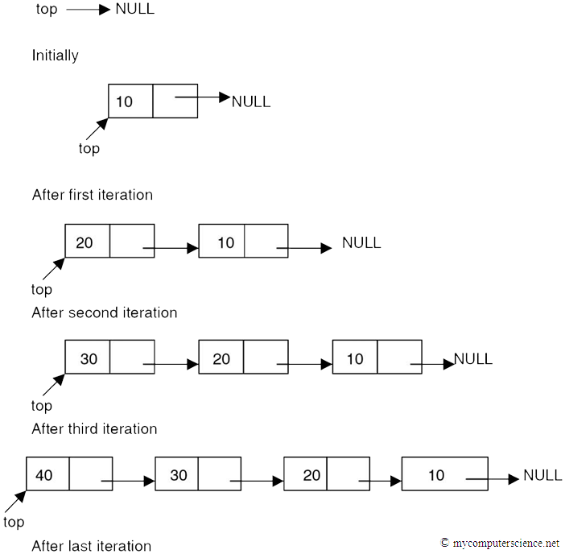

**Fig(c) Push operation using SLL**

1. **Expression conversion :-** Calculators employing reverse Polish notation use a stack structure to hold values. Expressions can be represented in prefix, postfix or infix notations. Conversion from one form of the expression to another form may be accomplished using a stack. Many compilers use a stack for parsing the syntax of expressions, program blocks etc. before translating into low level code. Most of the programming languages are context-free languages allowing them to be parsed with stack based machines.

**Examples**

***Infix expression (2 * 5 - 1 * 2) / (11 – 9)***

***Postfix Expression 2 5 * 1 2 * - 11 9 - /***

**Algorithm :**

**Infix String :** a+b*c-d

* 1. Read an item from input infix expression
  2. If item is an operand append it to postfix string
  3. If item is “(“ push it on the stack
  4. If the item is an operator and top of the stack(tos) is also operator
     1. If the operator has higher precedence than the one on tos then push it onto the operator stack
     2. If the operator has lower or equal precedence than the one on tos then
        1. pop the operator on tos and append it to postfix string( repeat if tos is again an operator)
        2. push lower precedence operator onto the stack
  5. If item is “)” pop all operators from tos one-by-one and append it to postfix string, until a “(“ is encountered on stack. Remove “(“ from tos and discard it.
  6. If end of infix string, pop the items from tos one-by-one and append to the postfix string. If other than operator anything is encountered on the stack at this step, then declare input as invalid input.

***Infix String : a+b*c-d***

***Postfix String : abc*+d-***

**Activity :**

1. Implement “dynamic stack” with following functions
   1. **void createStack(void)** **:** Create and initialize the top to NULL, creating the empty stack.
   2. **void push(char x)** **:** Creates a node with value 'x' and inserts on top of the stack.
   3. **char pop(void)** **:** Deletes a node from top of the stack and returns the deleted value.
   4. **boolean isEmpty(void)** **:** Returns “1” for stack empty; “0” otherwise.
   5. **char peek(void)** **:** Return current stack top element.

**NOTE :** Map appropriate methods of SLL with the methods of STACK and use.

1. **Implement expression conversion**
   1. Implement the above algorithm given for INFIX to POSTFIX expression conversion.

**Results:** A program depicting the correct behaviour of stack in conversion of expression and capable of handling all possible exceptional conditions and the same is reflected clearly in the output.

**Program and Output:**

Stack Implementation using Array:

#include <stdio.h>

#include <stdlib.h>

#define MAX 20

struct stack{

int TOP, a[MAX];

}s;

int i;

int main()

{

int choice;

printf("\n1.PUSH\n2.POP\n3.PEEK\n4.IsEmpty\n5.IsFull\n6.Exit\n");

printf("\nChoose an option: ");

scanf("%d",&choice);

switch(choice)

{

case 1:

s.TOP=-1;

push();

main();

break;

case 2:

pop();

main();

break;

case 3:

peek();

main();

break;

case 4:

if(isempty())

printf("Stack is empty.\n");

else

printf("Stack is not empty.\n");

main();

break;

case 5:

if(isfull())

printf("Stack is full.\n");

else

printf("Stack is not full.\n");

main();

break;

case 6:

break;

default:

printf("Choose a valid option!");

break;

}

return 0;

}

int push()

{

int val;

if(s.TOP==MAX-1)

{

printf("Stack overflow.\n");

}

else

{

while(val!= -1)

{

printf("Enter any number to be inserted in the stack(Enter -1 to stop): ");

scanf("%d",&val);

s.TOP=s.TOP+1;

s.a[s.TOP]=val;

}

printf("Stack Elements:\n");

for(i=s.TOP;i>-1;i--)

{

if (s.a[i]!=-1)

{

printf("%d\n",s.a[i]);

}

}

}

return s.TOP;

}

int pop()

{

if(s.TOP==-1)

{

printf("Stack underflow.\n");

}

else

{

int x;

s.TOP--;

x = s.a[s.TOP];

s.TOP=s.TOP-1;

printf("The popped element is: %d\n",x);

printf("Stack Elements after popping:\n");

for(i=s.TOP;i>-1;i--)

{

printf("%d\n",s.a[i]);

}

}

return s.TOP;

}

int peek()

{

if(s.TOP==-1)

{

printf("Stack is empty.\n");

}

else

{

printf("Top element: %d\n",s.a[s.TOP]);

}

}

int isempty()

{

if(s.TOP==-1)

{

return 1;

}

else

{

return 0;

}

}

int isfull()

{

if(s.TOP==MAX-1)

{

return 1;

}

else

{

return 0;

}

}

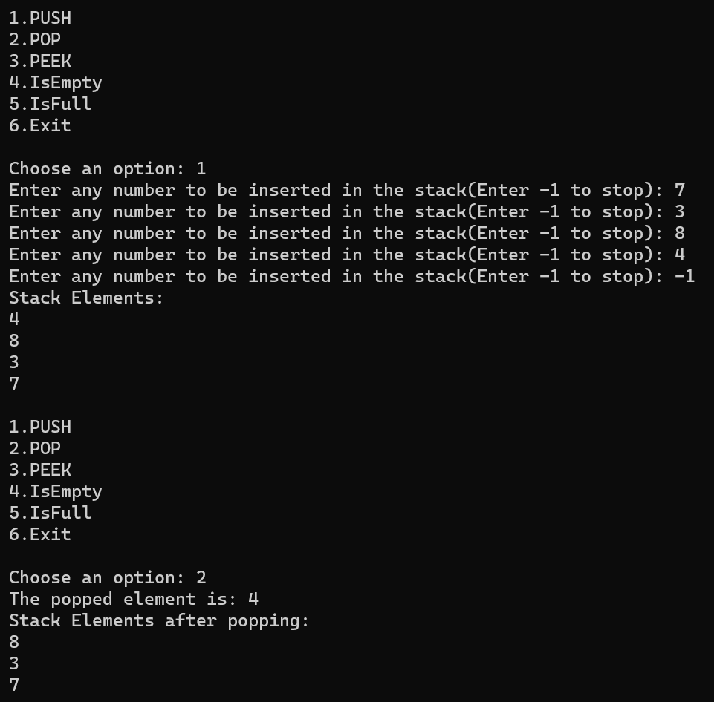

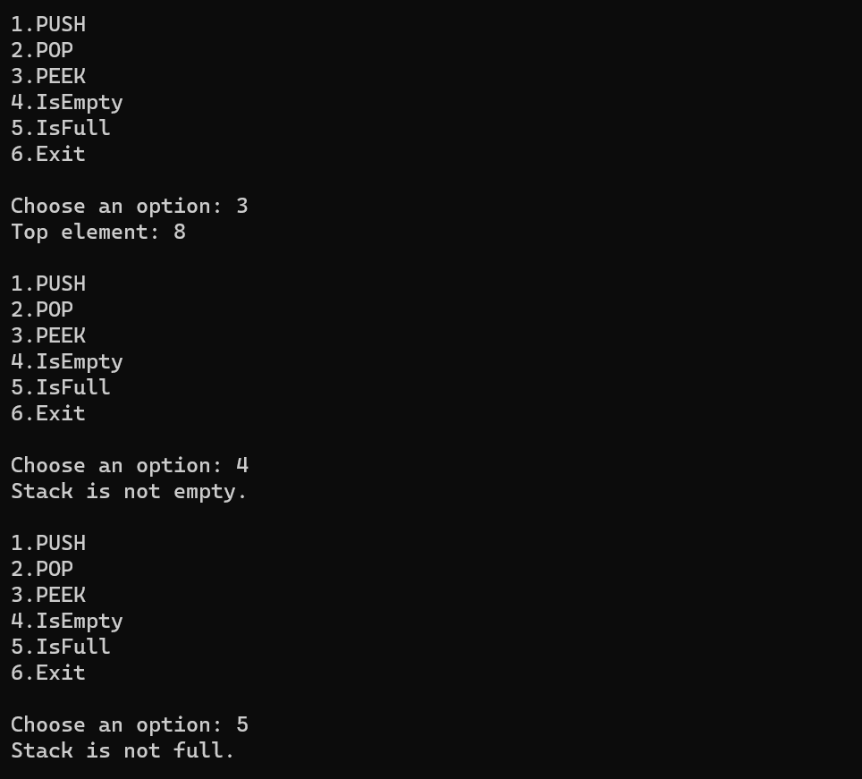

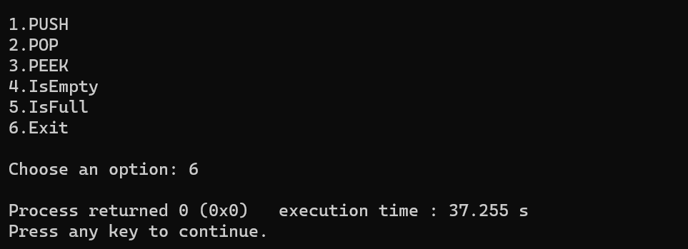

Infix to Postfix:

#include<stdio.h>

#include<string.h>

#include<ctype.h>

#define MAX 100

struct stack{

int TOP;

char a[MAX];

}s;

int main()

{

s.TOP=-1;

char infix[100],postfix[100];

printf("Enter the infix expression to be converted into postfix: ");

fgets(infix,sizeof(infix),stdin);

infix[strcspn(infix, "\n")] = '\0';

InfixToPostfix(infix,postfix);

printf("\nThe corresponding postfix expression is: %s",postfix);

return 0;

}

void push(char val)

{

if(s.TOP==MAX-1)

printf("\nStack overflow.");

else

{

s.TOP=s.TOP+1;

s.a[s.TOP]=val;

}

}

char pop()

{

char val='\0';

if(s.TOP==-1)

printf("\nStack underflow.");

else

{

val = s.a[s.TOP];

s.TOP=s.TOP-1;

}

return val;

}

int OperatorPriority(char op)

{

if(op=='^')

return 2;

else if(op=='*'||op=='/'||op=='%')

return 1;

else if(op=='+'||op=='-')

return 0;

else

return -1;

}

void InfixToPostfix(char source[],char target[])

{

int i=0,j=0;

char temp;

strcpy(target,"");

while(source[i]!='\0')

{

if(source[i]=='(')

{

push(source[i]);

i++;

}

else if(source[i]==')')

{

while(s.TOP!=1 && s.a[s.TOP]!='(')

{

target[j]=pop();

j++;

}

if(s.TOP==-1)

{

printf("\nInvalid infix expression!");

}

temp=pop();

i++;

}

else if(isdigit(source[i])||isalpha(source[i]))

{

target[j]=source[i];

j++;

i++;

}

else if(source[i]=='+'||source[i]=='-'||source[i]=='*'||source[i]=='/'||source[i]=='%'||source[i]=='^')

{

while((s.TOP!=-1) && (s.a[s.TOP]!='(') && (OperatorPriority(s.a[s.TOP])>=OperatorPriority(source[i])))

{

target[j] = pop();

j++;

}

push(source[i]);

i++;

}

else

{

printf("\nInvalid infix expression!");

return;

}

}

while(s.TOP!=-1 && s.a[s.TOP]!='(')

{

target[j]=pop();

j++;

}

target[j]='\0';

}

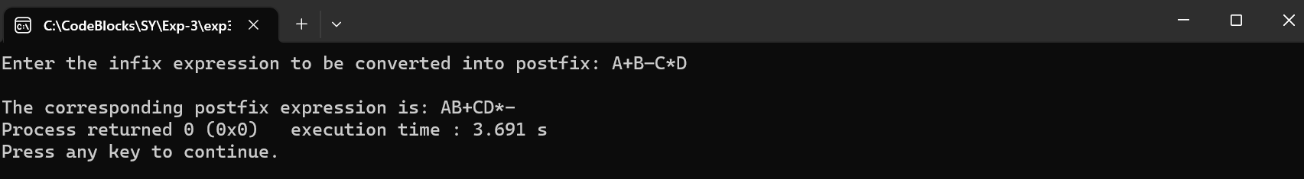

Stack Implementation using Linked Lists:

#include <stdio.h>

#include <stdlib.h>

#include <conio.h>

#include <malloc.h>

struct stack{

int data;

struct stack *next;

}s;

struct stack *top = NULL;

int main()

{

int choice, val;

printf("\n1.PUSH\n2.POP\n3.PEEK\n4.IsEmpty\n5.IsFull\n6.Exit\n");

printf("\nChoose an option: ");

scanf("%d",&choice);

switch(choice)

{

case 1:

printf("\nEnter the number to be pushed on stack: ");

scanf("%d", &val);

top = push(top, val);

display(top);

main();

break;

case 2:

pop();

main();

break;

case 3:

peek();

main();

break;

case 4:

if(isempty())

printf("Stack is empty.\n");

else

printf("Stack is not empty.\n");

main();

break;

case 5:

printf("A stack that is dynamically implemented using linked lists can never be full.\n");

main();

break;

case 6:

break;

default:

printf("Choose a valid option!");

break;

}

return 0;

}

struct stack *push(struct stack *top, int val)

{

struct stack *newnode;

newnode = (struct stack*)malloc(sizeof(struct stack));

newnode -> data = val;

if(isempty())

{

newnode -> next = NULL;

top = newnode;

}

else

{

newnode -> next = top;

top = newnode;

}

return top;

}

struct stack *display(struct stack *top)

{

struct stack *newnode;

newnode = top;

if(isempty())

printf("\n STACK IS EMPTY");

else

{

while(newnode != NULL)

{

printf("\n %d", ptr -> data);

newnode = newnode -> next;

}

}

return top;

}

struct stack *pop(struct stack *top)

{

struct stack *ptr;

ptr = top;

if(isempty())

{

printf("Stack underflow.\n");

}

else

{

top = top->next;

printf("The popped element is: %d\n", ptr -> data);

free(ptr);

}

return top;

}

int peek()

{

if(isempty())

{

printf("Stack is empty.\n");

}

else

{

printf("Top element: %d\n",top -> data);

}

}

int isempty(struct stack *top)

{

if(top==NULL)

{

return 1;

}

else

{

return 0;

}

}

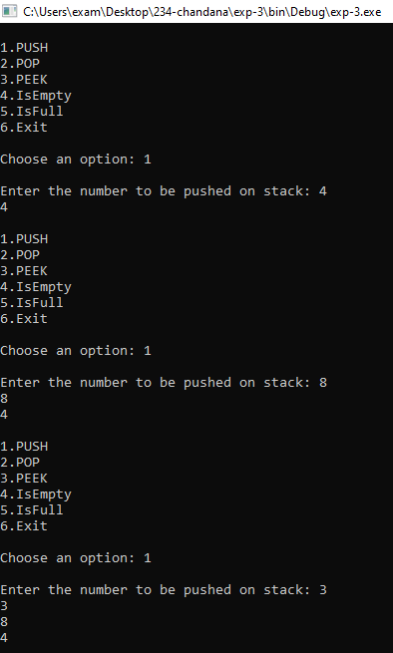

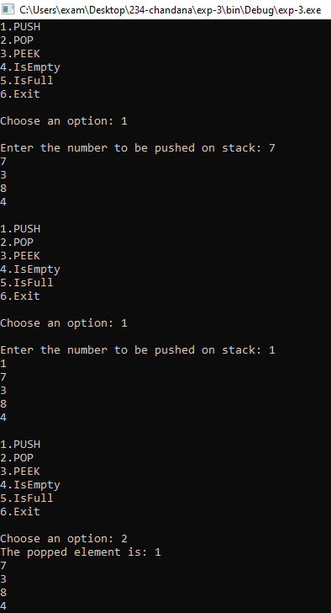

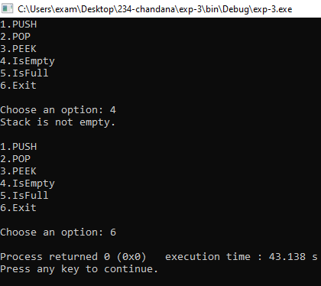

Infix to Postfix:

#include <stdio.h>

#include <stdlib.h>

#include <conio.h>

#include <malloc.h>

struct Node

{

char data;

struct Node* next;

};

struct Node* createNode(char data)

{

struct Node* newNode = (struct Node*)malloc(sizeof(struct Node));

newNode->data = data;

newNode->next = NULL;

return newNode;

}

int isEmpty(struct Node* top)

{

return top == NULL;

}

void push(struct Node** top, char data)

{

struct Node* newNode = createNode(data);

newNode->next = *top;

*top = newNode;

}

char pop(struct Node** top)

{

if (isEmpty(*top))

{

printf("Stack underflow!\n");

exit(EXIT_FAILURE);

}

struct Node* temp = *top;

char data = temp->data;

*top = (*top)->next;

free(temp);

return data;

}

int getPrecedence(char op)

{

if (op == '+' || op == '-')

return 1;

else if (op == '*' || op == '/')

return 2;

else if (op == '^')

return 3;

else

return 0;

}

void infixToPostfix(char* infix)

{

struct Node* stack = NULL;

char postfix[100];

int i, j;

i = j = 0;

while (infix[i] != '\0')

{

if (isalpha(infix[i]))

{

postfix[j++] = infix[i];

}

else if (infix[i] == '(')

{

push(&stack, infix[i]);

}

else if (infix[i] == ')')

{

while (!isEmpty(stack) && stack->data != '(')

{

postfix[j++] = pop(&stack);

}

if (!isEmpty(stack) && stack->data != '(')

{

printf("Invalid infix expression!\n");

return;

}

else

{

pop(&stack);

}

}

else

{

while (!isEmpty(stack) && getPrecedence(infix[i]) <= getPrecedence(stack->data))

{

postfix[j++] = pop(&stack);

}

push(&stack, infix[i]);

}

i++;

}

while (!isEmpty(stack))

{

postfix[j++] = pop(&stack);

}

postfix[j] = '\0';

printf("Postfix expression: %s\n", postfix);

}

int main()

{

char infix[100];

printf("Enter the infix expression: ");

scanf("%s", infix);

infixToPostfix(infix);

return 0;

}

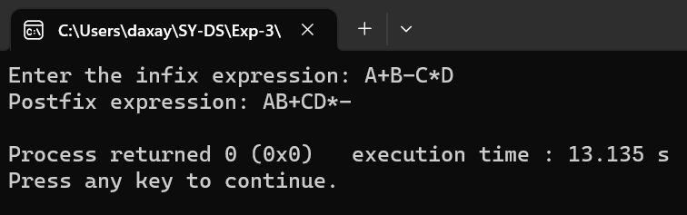

**Outcomes:**

Apply linear and non-linear data structure in application development.

**Conclusion:**

The experiment demonstrated the successful implementation of a stack using a singly linked list and the correct execution of the specified operations. Additionally, the experiment showcased the effectiveness of the stack implementation in converting infix expressions to postfix form.

**Grade: AA / AB / BB / BC / CC / CD /DD**

**Signature of faculty in-charge with date _______________________________________________________________________**

**References:**

**Books/ Journals/ Websites:**

* Y. Langsam, M. Augenstin and A. Tannenbaum, “Data Structures using C”, Pearson Education Asia, 1st Edition, 2002